**Docker Network**

**Docker network ls : to see all networks**

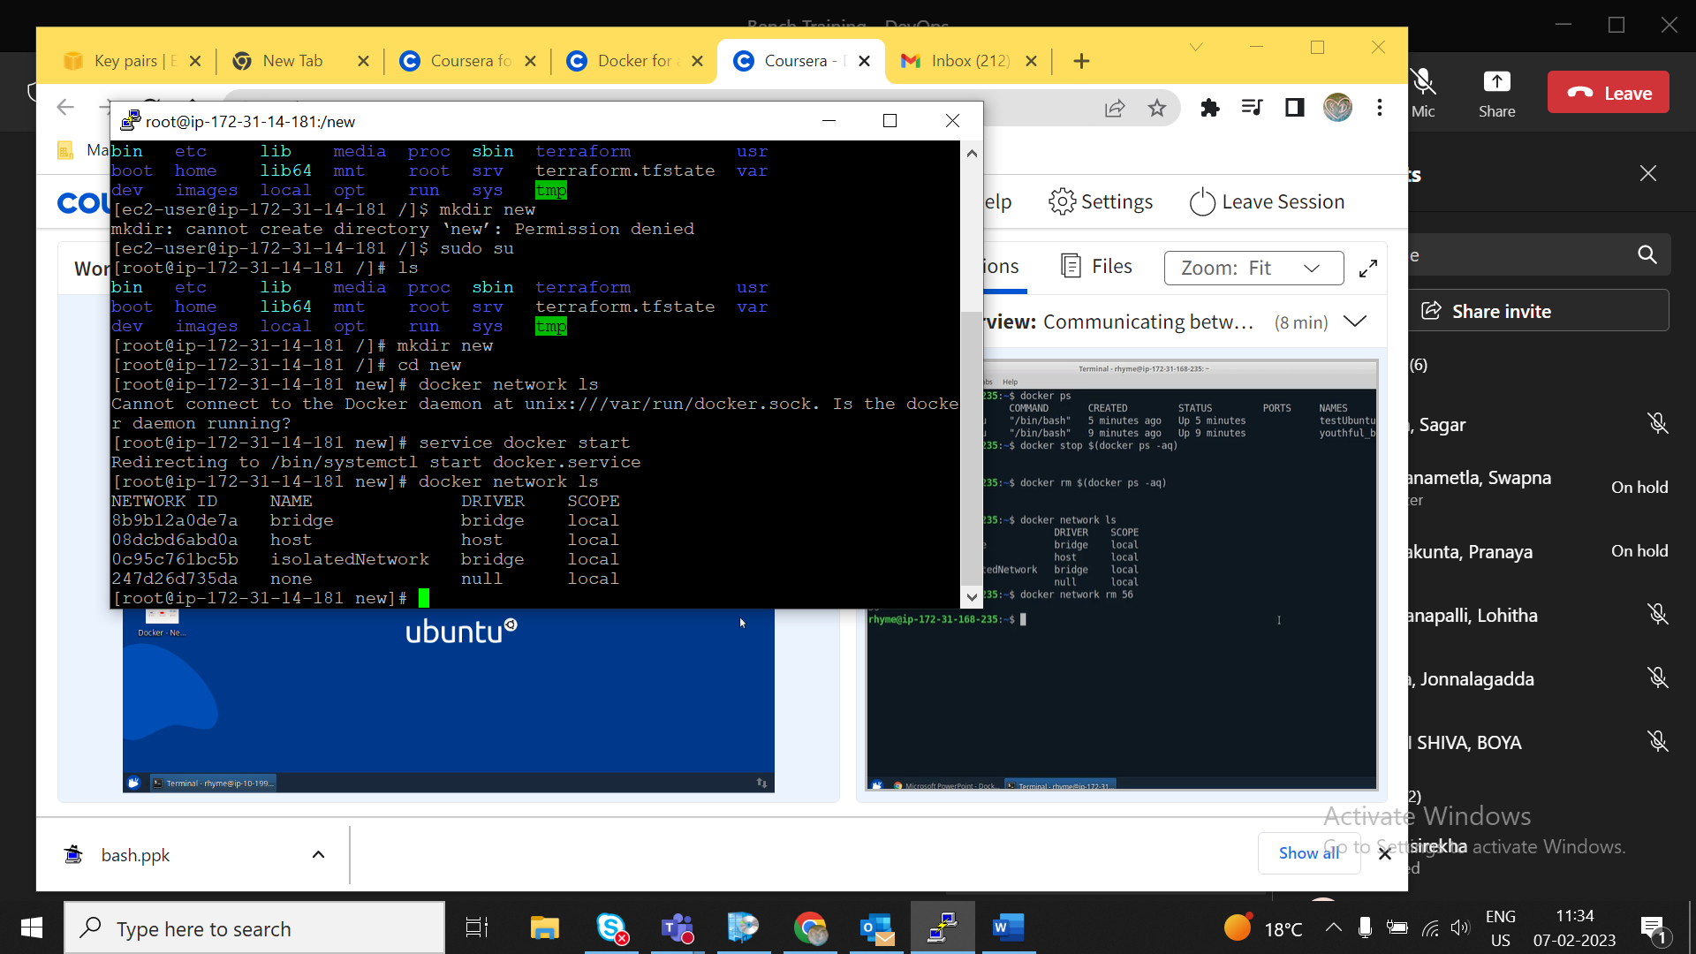

**Docker network prune : to delete all unused network**

**Docker network rm networkid : to delete particular network**

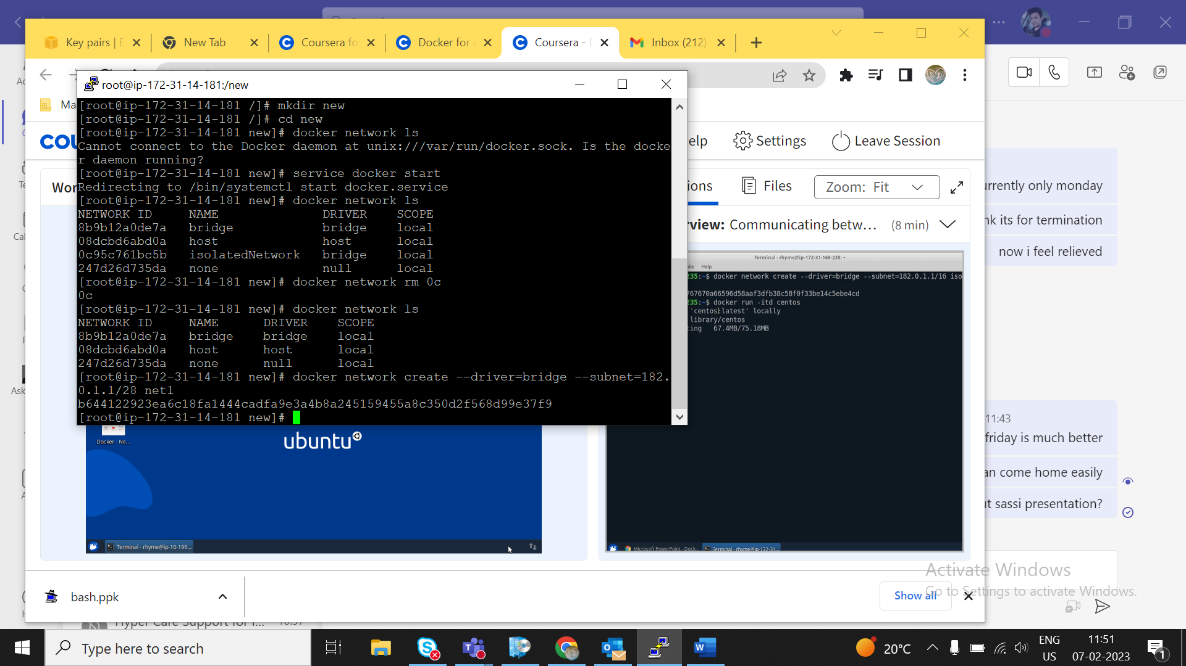

**Docker network create -o --subnet=192.168.1.0/24 networkName**

**{{used to create network}**

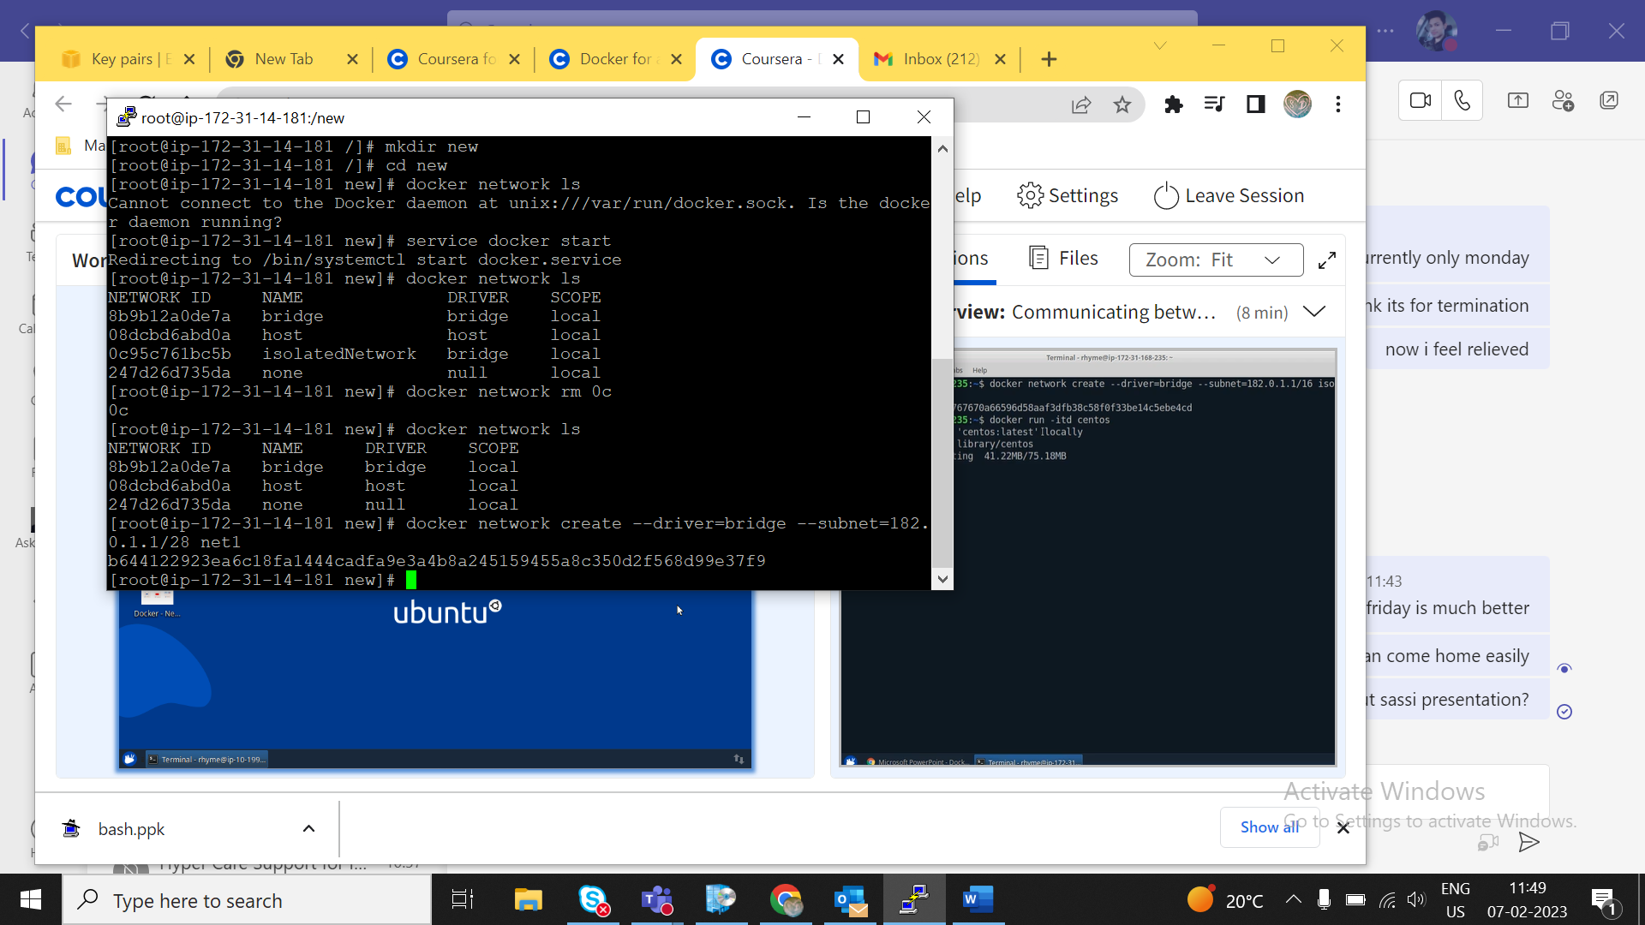

**Docker network connect networkname containerid : to connect container to network**

**Docker network disconnect networkname containerid : to disconnect**

**Docker network inspect <networked> : information about network**

**Docker container run -itd –name=<containername> --net=networkname ubuntu**

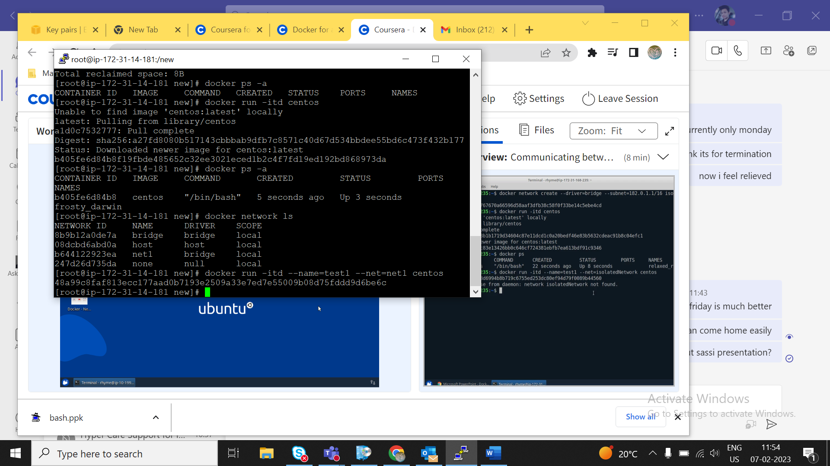

**Communication between container on same network**

**{if we ping one container from second container,it will show its configurations i.e they are connected}**

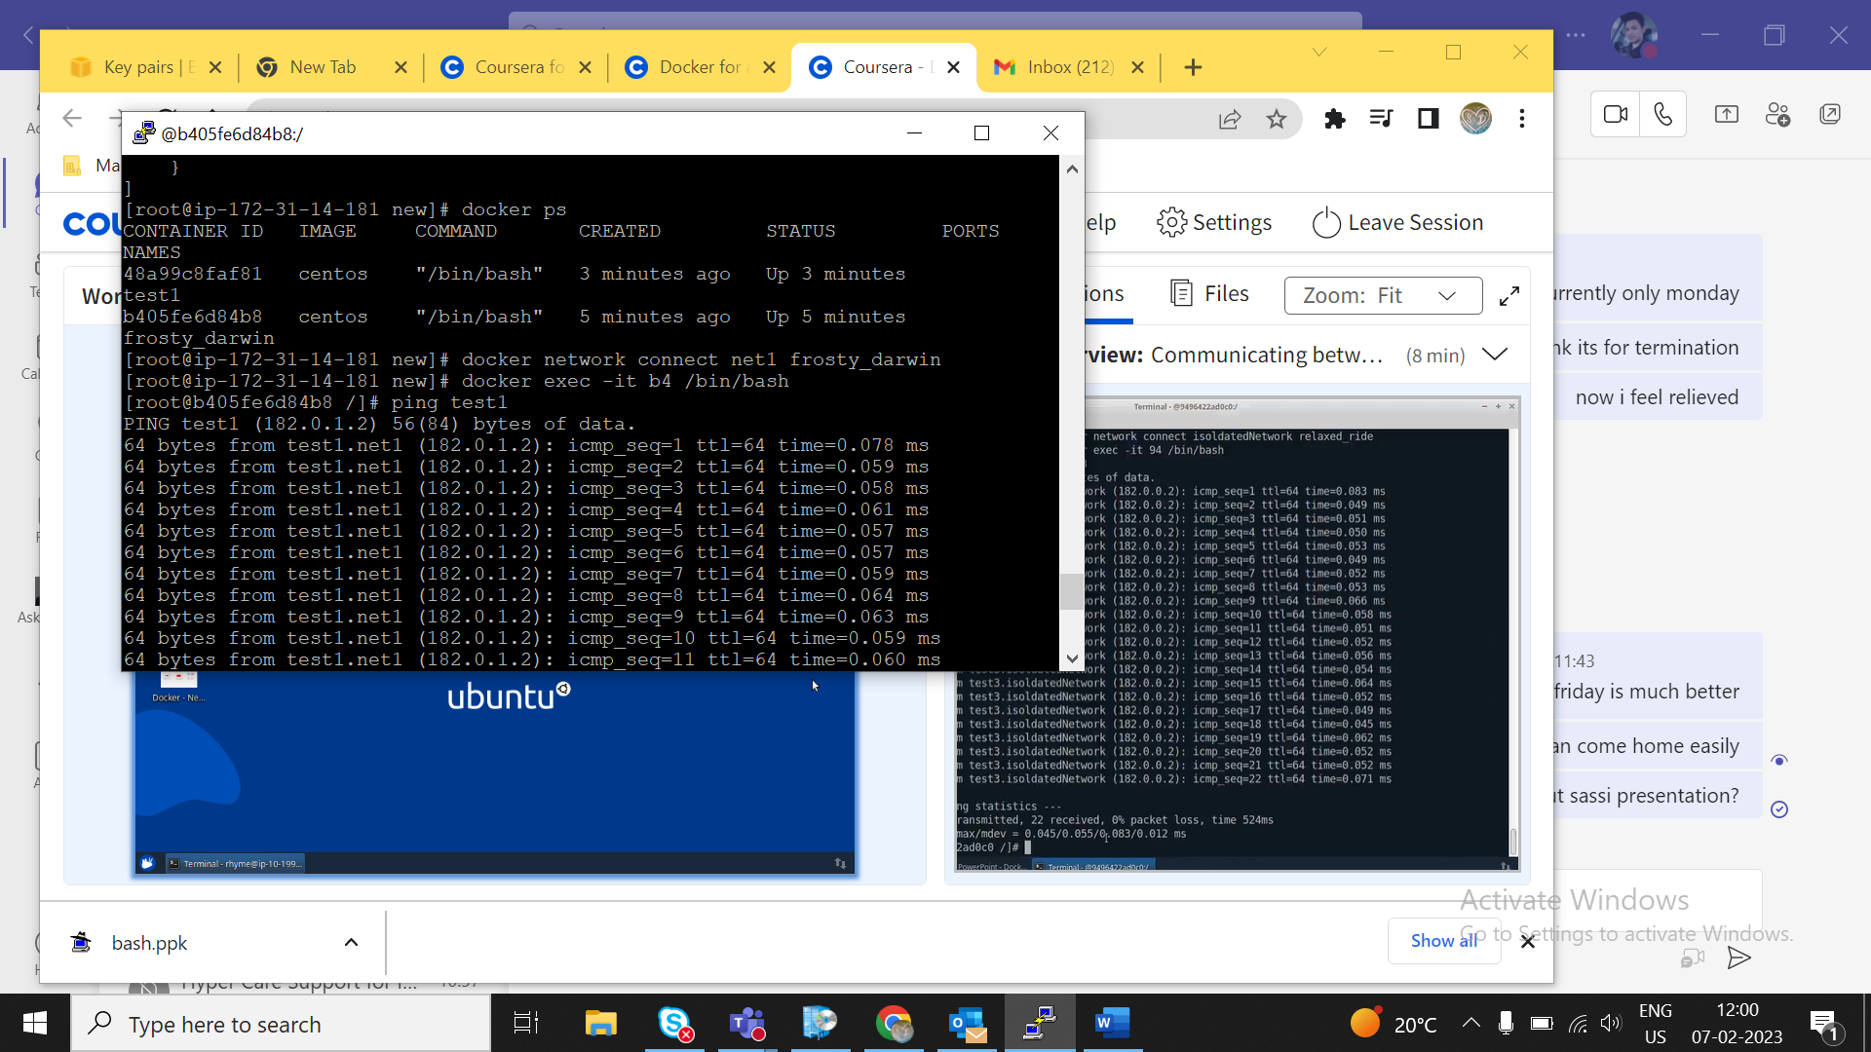

**Docker volumes**

**Docker volume create volumename : to create volumes**

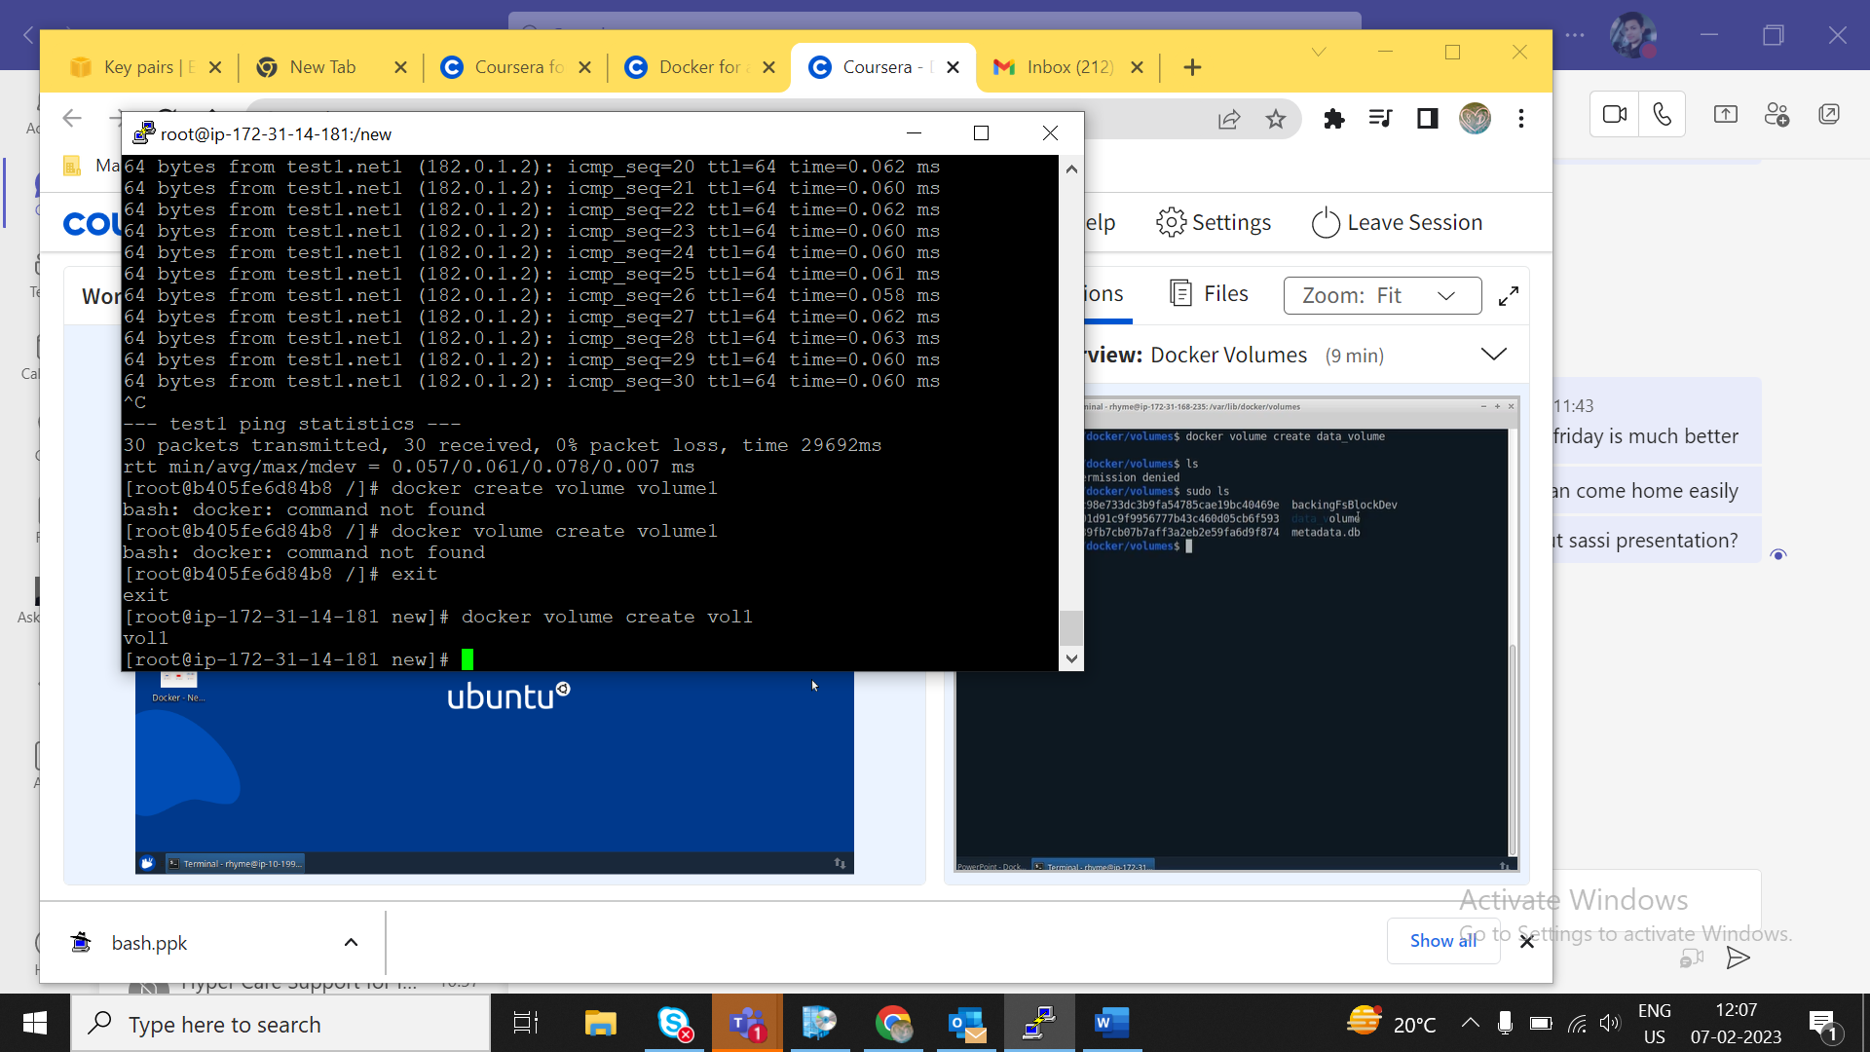

**Docker run -itd -v volumename:/containerdir ubuntu**

**{{ it will bound volume to containerdir}}**

**Everything we do in containerdir,it will store it in volume**

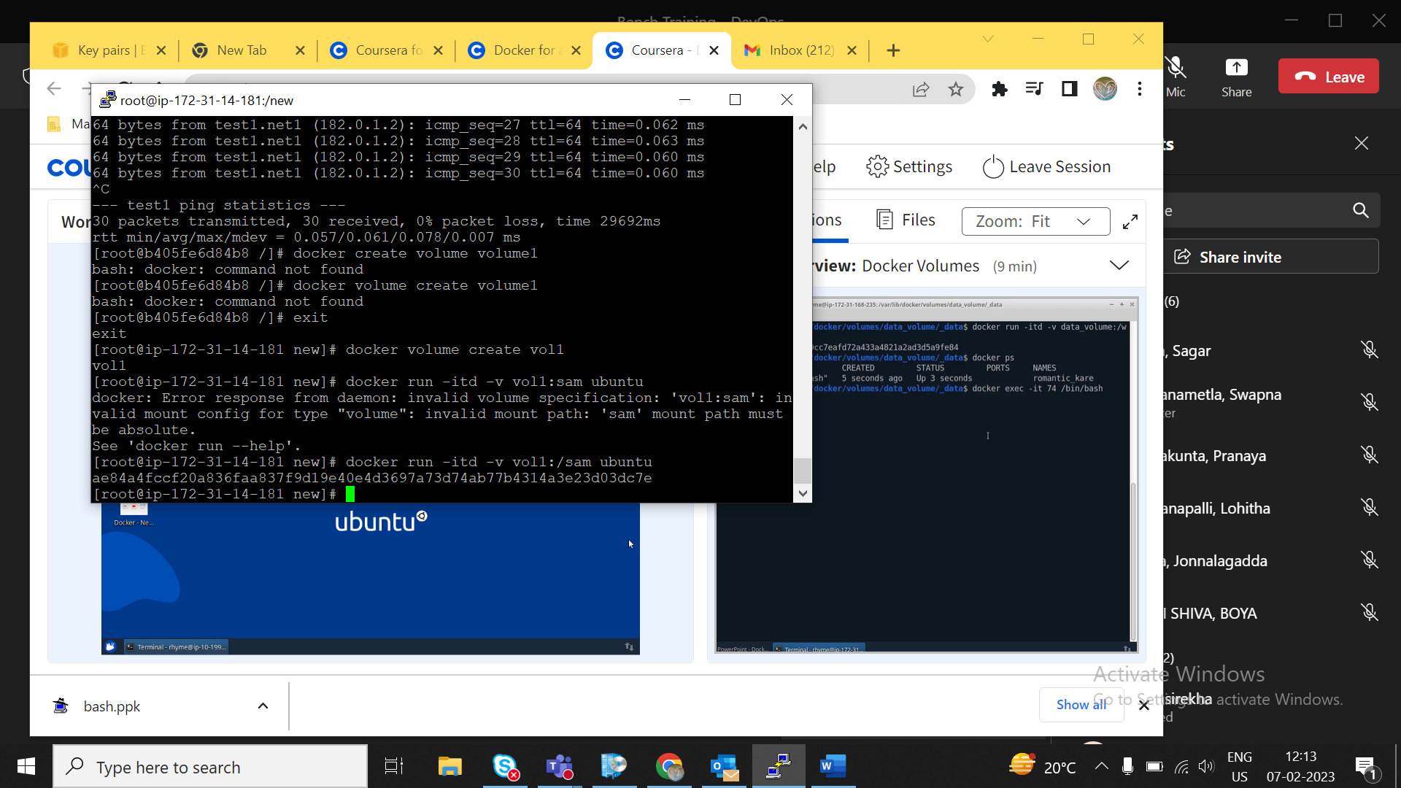

**If we go to container and create something there,it will reflect it in volumedir**

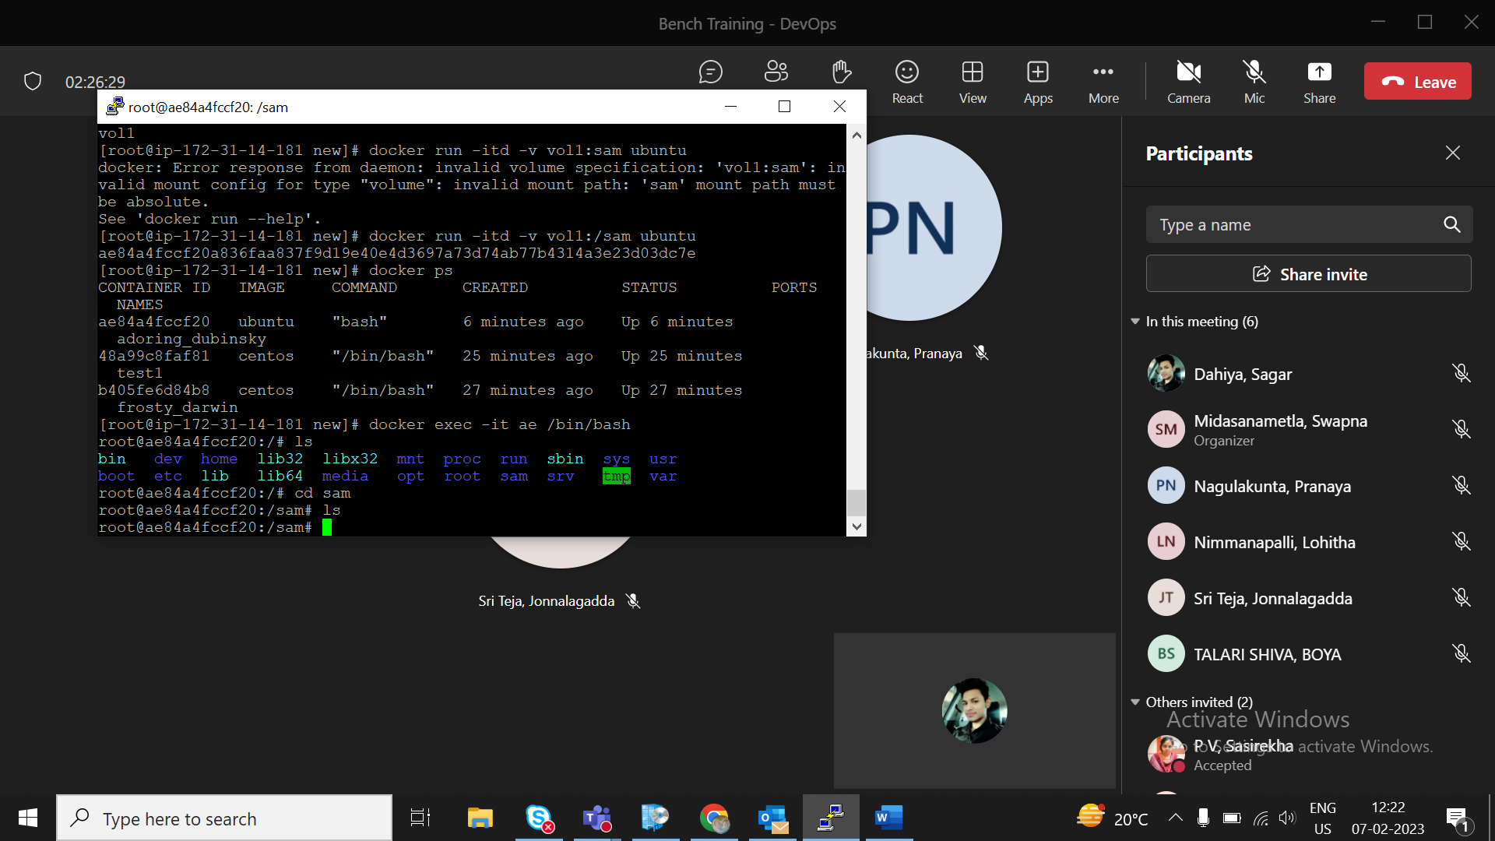

**We create three files a,b,c in sam folder**

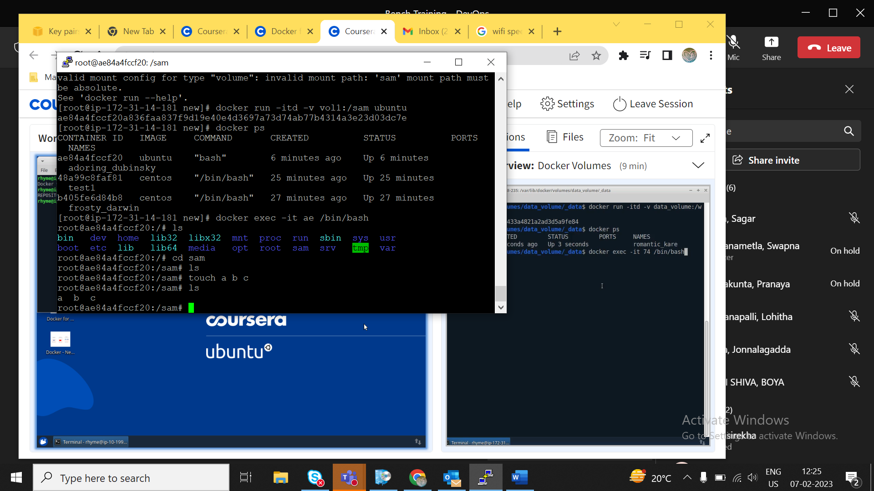

**Now we check it in volumedir**

**Go to /var/docker/volumes/vol1**

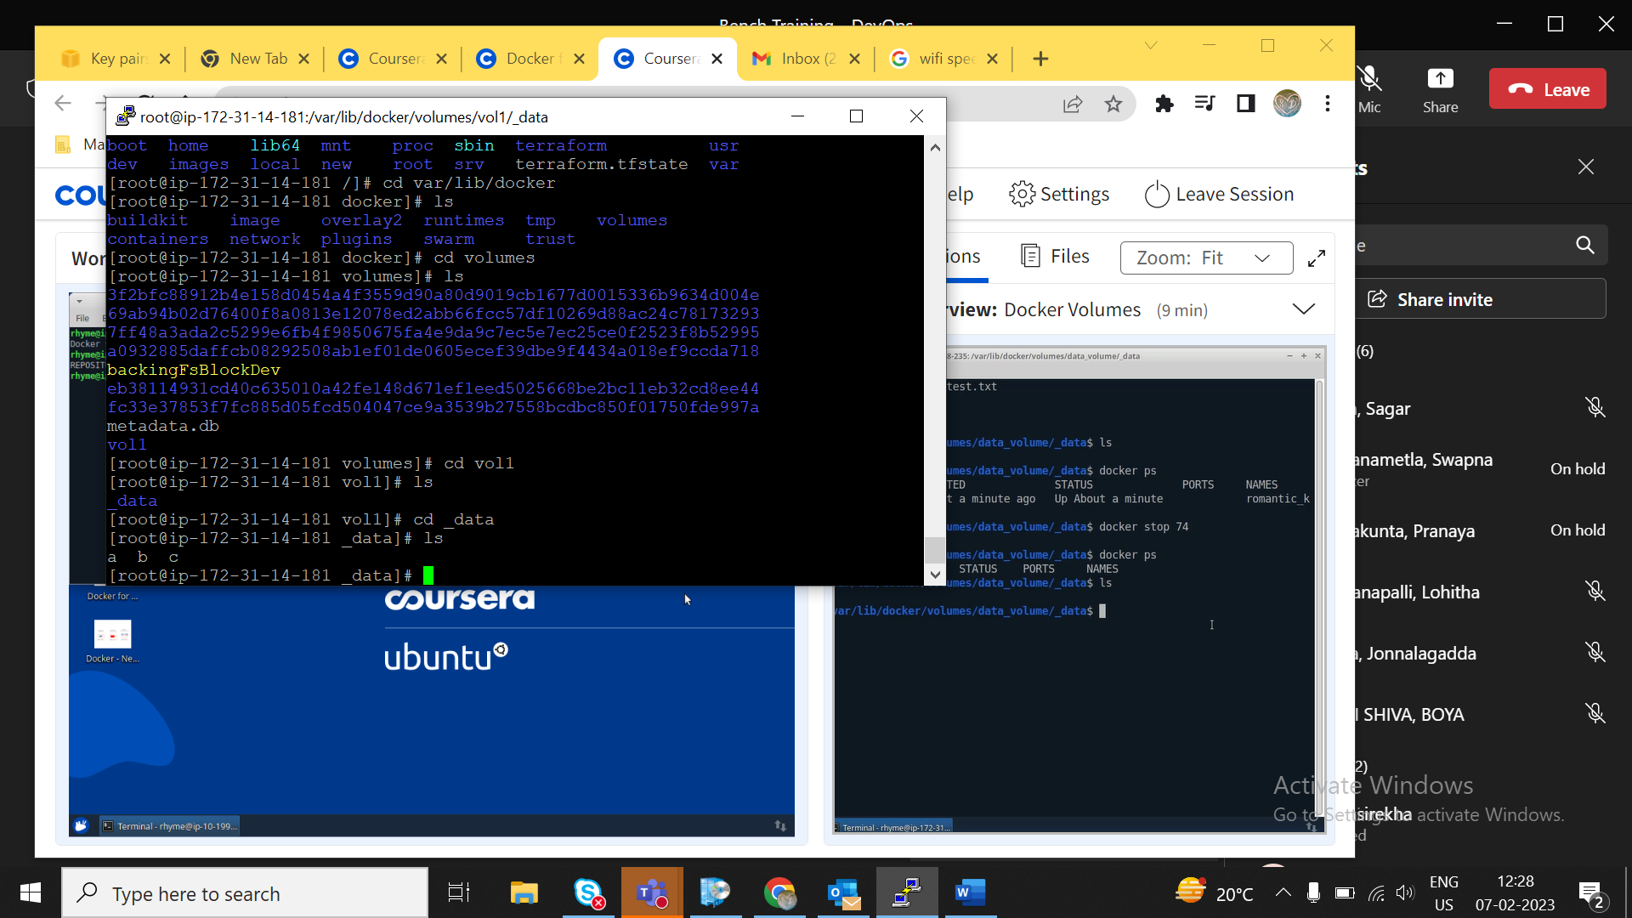

**We found all three files here**

**Docker mount method :**

**docker run -itd -mount type=bind,source=/home/vol1,target=/containerdir1 ubuntu**

**{{ it will bind containerdir to dir in instance}}**

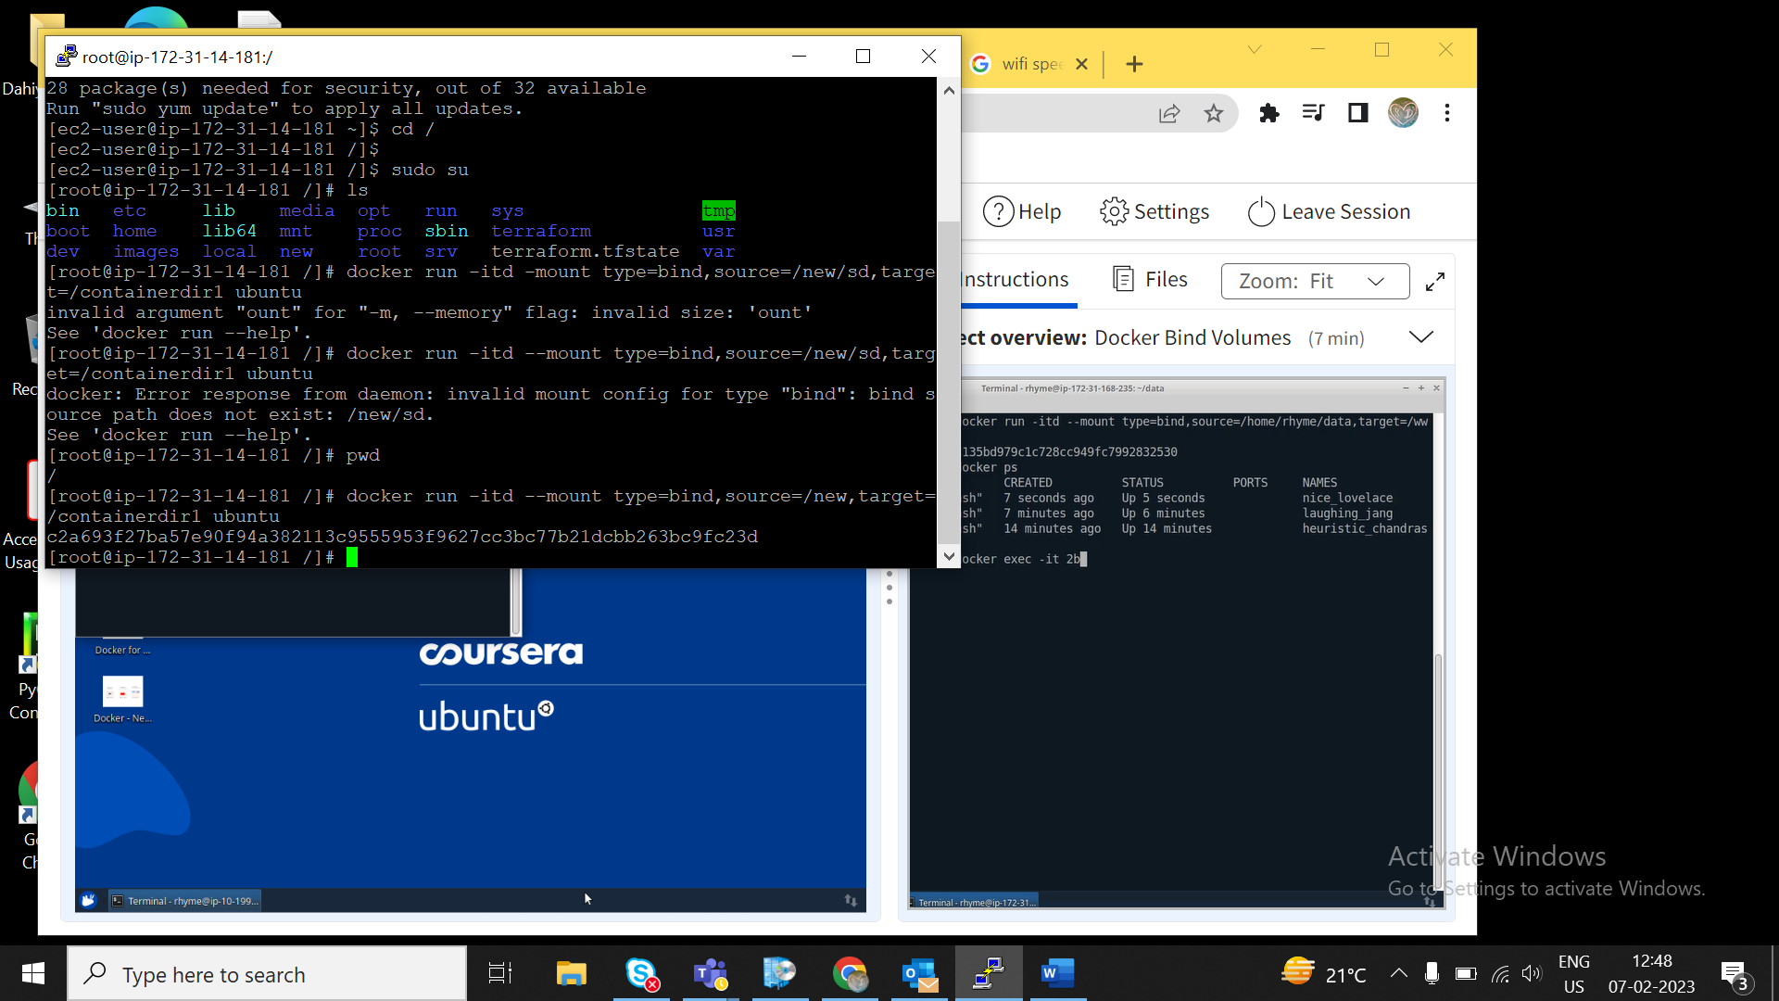

**Docker volume rm volumename : to delete volume**

